RAQUEL CIPRIANO
hi.raquelcipriano@gmail.com | +44 (0)7405213773 | Equity Member
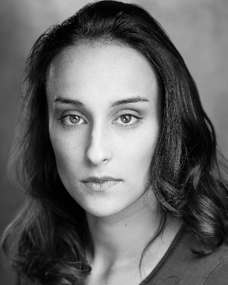
Eyes Green Hair Dark Brown Height 5´5 Built petit
SKILLS Singing (Mezzo Soprano), Ballet, Jazz, Contemporary, Basic Stage Combat
LANGUAGES Portuguese (native), English and Italian (fluent), Spanish and French (basic)
ACCENTS British, General American, Portuguese (native), Brazilian, Italian, French
Spotlight 5495-7861-3185 | IMDB | Show-Reel https://vimeo.com/281811266

FILM
NIGHT TRAIN TO LISBON Maria Dir. Bille August C-Films AG and more
FLORBELA Nurse Dir. Vicente Alves do Ó Ukbar Films
HEAVEN* Ker Dir. Adam Kennedy Independent
DUST** Musician Dir. Ella Bennet NFTS and ENO
BHAIJAAN Dancer Dir. Joydeep Mukherjee Eskay Films
THE SENTIENT Noah Dir. Amba hamilton Independent
THE PRESENT Grace Dir. Alexandra Oliveira Independent
UNTITLED Ines Dir. Mischa Andreski (In Pre-production)
MARIA Rita Dir. Alexandra Oliveira (In Pre-production)
*Los Angeles Neo Noir Film Festival 2019 and The Berlin Flash Film Festival 2019
**Future Filmmakers Festival 2019 and Cinema Talks 2019

TV
SIGNS OF LIFE Laura several directors SP Television
MATERNITY Joana several directors SP Television
THE TIME BETWEEN SEEMS Sira’s Double several directors Boomerang TV

THEATRE
THE ODD COUPLE Mickey Dir. Richard Pryal The Lost Theatre
ALL TINGS NICE Beau (Lead) Dir. David Hartley The Lost Theatre
RICHARD III Lady Anne Dir. Ávila Costa Teatro da Malaposta
FREI LUIS DE SOUSA Maria (Lead) Dir. Bruno Cunha T.C. Arte d’encantar
SPEAKING THE TRUTH LYING Amália Dir. Bruno Cunha T.C. Arte d’encantar
AUTO DA BARCA DO INFERNO Anjo Dir. Bruno Cunha T.C. Arte d’encantar

FURTHER CREDITS
CYLETEZO (Commercial) Friend Still Photography and video
THE BEGGAR’S OPERA (MT) Teresinha (Lead) Dir. Júnior Pessoa Teatro Ibérico
MISS SAIGON (MT) Gigi Dir. Sofia de Castro Teatro da Malaposta

TRAINING
Acting Coach sessions Sarah Leung, Casting Director, LONDON
ACTING Masterclass Bernard Hiller Masterclass, LONDON and LA
ACTING Programme American Musical Theatre Academy, LONDON
ACTING FOR SCREEN workshop Mathew Bonifacio, NY
RAQUEL CIPRIANO
hi.raquelcipriano@gmail.com | +44 (0)7405213773 | Equity Member
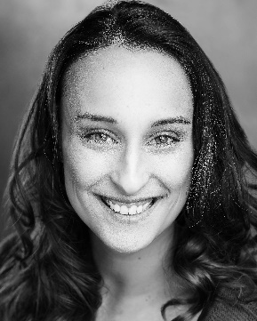
Eyes Green Hair Dark Brown Height 5´5 Built petit
SKILLS Singing (Mezzo Soprano), Ballet, Jazz, Contemporary, Basic Stage Combat
LANGUAGES Portuguese (native), English and Italian (fluent), Spanish and French (basic)
ACCENTS British, General American, Portuguese (native), Brazilian, Italian, French
Spotlight 5495-7861-3185 | IMDB | Show-Reel https://vimeo.com/281811266

FILM
NIGHT TRAIN TO LISBON Maria Dir. Bille August C-Films AG and more
FLORBELA Nurse Dir. Vicente Alves do Ó Ukbar Films
HEAVEN* Ker Dir. Adam Kennedy Independent
DUST** Musician Dir. Ella Bennet NFTS and ENO
BHAIJAAN Dancer Dir. Joydeep Mukherjee Eskay Films
THE SENTIENT Noah Dir. Amba hamilton Independent
THE PRESENT Grace Dir. Alexandra Oliveira Independent
UNTITLED Ines Dir. Mischa Andreski (In Pre-production)
MARIA Rita Dir. Alexandra Oliveira (In Pre-production)
*Los Angeles Neo Noir Film Festival 2019 and The Berlin Flash Film Festival 2019
**Future Filmmakers Festival 2019 and Cinema Talks 2019

TV
SIGNS OF LIFE Laura several directors SP Television
MATERNITY Joana several directors SP Television
THE TIME BETWEEN SEEMS Sira’s Double several directors Boomerang TV

THEATRE
THE ODD COUPLE Mickey Dir. Richard Pryal The Lost Theatre
ALL TINGS NICE Beau (Lead) Dir. David Hartley The Lost Theatre
RICHARD III Lady Anne Dir. Ávila Costa Teatro da Malaposta
FREI LUIS DE SOUSA Maria (Lead) Dir. Bruno Cunha T.C. Arte d’encantar
SPEAKING THE TRUTH LYING Amália Dir. Bruno Cunha T.C. Arte d’encantar
AUTO DA BARCA DO INFERNO Anjo Dir. Bruno Cunha T.C. Arte d’encantar

FURTHER CREDITS
CYLETEZO (Commercial) Friend Still Photography and video
THE BEGGAR’S OPERA (MT) Teresinha (Lead) Dir. Júnior Pessoa Teatro Ibérico
MISS SAIGON (MT) Gigi Dir. Sofia de Castro Teatro da Malaposta

TRAINING
Acting Coach sessions Sarah Leung, Casting Director, LONDON
ACTING Masterclass Bernard Hiller Masterclass, LONDON and LA
ACTING Programme American Musical Theatre Academy, LONDON
ACTING FOR SCREEN workshop Mathew Bonifacio, NY

